Sustainble new-build home built with Kebony façade adorns rugged Welsh coastline
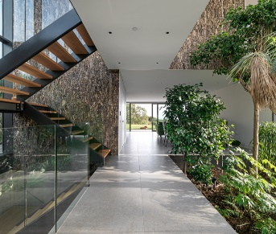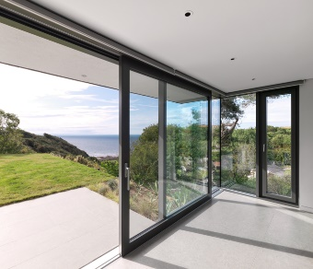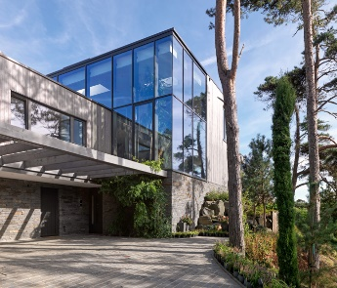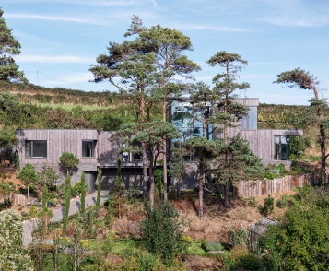
[London: 16 November 2021] Built into a rugged hillside overlooking the expensive natural coastline of the Gower peninsula, Wales, a new-build family home with a sustainable vision is now complete. Designed by award-winning architects, Loyn + Co, the home which blends naturally into the verdant landscape and sits beneath towering pine trees, makes extensive use of Kebony, a global leader in the production of sustainable wood, for the home’s façade.
The design brief for the new home was to make the most of the beautiful views, capturing the potential of the sensitive location, in addition to prioritising the contextual importance of the site, topography and existing trees. As keen gardeners, the clients also wanted a house that would be suitable for the warm months and harsher winters. The dwelling is partially cut into the site and organised to not only have wonderful sea views, but arranged so that a central atrium planted with specimen trees provides a winter garden as well as an inspiring circulation space serving each of the three levels and putting nature at the centre of the home.
The family home, which has been cut into the valley side amongst established trees, makes extensive use of Kebony wood, which diverts the need for deforestation by transforming sustainable wood species such as pine into Kebony wood with features that are comparable, and in some cases superior, to those of precious tropical hardwoods.
Following the COP26 climate summit which saw 100 world leaders promise to end and reverse deforestation by 2030, Loyn + Co’s decision to make extensive use of sustainably-sourced Kebony wood for the stunning new-build home reflects the global shift to favour sustainable materials in construction, which will soon become an imperative for architects, homebuilders and real estate developers to rapidly curb the impacts of climate change, including the destruction of trees which depletes forests that absorb vast amounts of CO2.
James Stroud, Director at Loyn + Co Architects, commented: “The new home has been thoughtfully knitted into this complex site to work with the varying levels and existing beautiful trees. The design truly brings the outside in, not only through ‘inside outside spaces’ and visual links through the house to the sea beyond, but through the indoor garden within the central atrium where nature is the focus. Simple measures such as bringing the Kebony cladding in and through the atrium reinforces this concept.”
Nina Landbø, International Sales Manager at Kebony, added – “It’s fantastic to see more and more homes embrace the use of sustainably sourced wood like Kebony, which decreases the logging of precious tropical hardwoods and provides a long-lasting and sustainably-sourced wood alternative to concrete, plastic and steel. The architects, Loyn + Co have created a truly special home in Wales, and one that should set an example for how remarkable homes can be created and benefitted by innovative, environmentally-friendly materials.”
Kebony is a Norwegian company which aims to be the leading wood brand and technology company. The company’s revolutionary technology is an environmentally friendly process which modifies sustainably sourced softwoods by heating the wood with furfuryl alcohol - an agricultural by-product. By polymerising the wood’s cell wall, the softwoods permanently take on the attributes of tropical hardwood including high durability, hardness, and dimensional stability

-Ends-

Images: Charles Hosea

www.kebony.com

- @KebonyWood

https://loyn.co.uk/
@loynco

Media Enquiries:
Interviews, case studies, images available from:
Melissa Carver/ Gordon Cole-Schmidt
The Communication Group
T: +44 (0)20 7630 1411
E: kebony@thecommunicationgroup.co.uk

Notes to editors:

About Kebony
Kebony is a Norwegian company which aims to be the leading wood brand and technology company. Underpinned by proven wood modification technologies, it produces an enhanced wood of a superior quality that is both environmentally friendly and cost-effective.

The company's headquarters is based in Oslo, while production, research and development and other administrative functions are located in the Skien municipality, south of Oslo. In addition, the Group has a production facility in Antwerp, Belgium. Kebony has subsidiaries in Norway, Denmark and Sweden, sales representatives in Germany, France, UK and the US and a wide distribution network internationally. Shareholders are leading the venture with private equity investors from Belgium, Germany, France, Norway and UK. The company has received numerous awards for its environmentally friendly technology and innovation, including its naming as a World Economic Forum Technology Pioneer.
The Kebony® technology permanently transforms sustainable wood species such as pine into Kebony wood with features that are comparable, and in some cases superior, to those of precious tropical hardwoods. This unique environmentally friendly process is also a superior alternative to traditional wood treatment based on impregnation with biocides (wood preservatives). The company’s patent-protected production processes yield products that deliver major improvements in durability and dimensional stability, at the same time as being highly attractive. The Kebony products are suitable for a multitude of applications and designs – encompassing both indoor and outdoor applications.
In October 2021, Kebony announced the closure of a EUR 30m investment round led by Jolt Capital and Lightrock.
About Loyn + Co
LOYN + CO Architects were established by Principal Architect Chris Loyn in 1992, based in Penarth, South Wales, LOYN + CO has gained a reputation for realising creative, imaginative and contextual architecture. During its history the practice has enjoyed recognition for its achievements in architecture through published projects and many significant awards and nominations.
The practice has established a specialism in residential schemes recognised by numerous Housing Awards granted over the years, including in 2014 the RIBA’s award for the best new home in Britain, the ‘Manser Medal’ for Stormy Castle, situated in an Area of Outstanding Natural Beauty and ‘Building of the Year’ RIBA Regional Awards for both 2015 and 2016. Their most recent project to be awarded Building of the Year, ‘Outhouse’ has been described in the Architects Journal as ‘one of the most outstanding new houses in Britain in a decade’. ‘Outhouse’ has gone on to receive recognition from the public, architectural press and the RIBA including most significantly being included on the shortlist for the Stirling Prize and winning the BBC’s ‘Peoples vote’ for the RIBA Stirling Prize. In addition the practice has been awarded The Sunday Times British Homes Award for one-off house over 5,000 sq ft and once again the prestigious ‘Manser Medal’ 2016 - the first time the award has been given to the same practice twice.
The Practice is a long standing supporter of contemporary Architecture in Wales promoting, and exhibiting as well as regularly teaching at the Welsh School of Architecture and other architecture schools in the UK. The practice has been awarded the respected Eisteddfod Gold Medal in 2007, 2014 and 2015. In addition to projects in Wales the practice operates on sites across the UK with current projects situated in Dorset, Cotswolds, and London.

